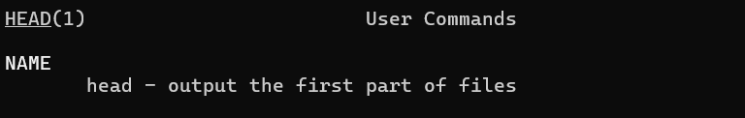
The head command outputs the first parts of a file.
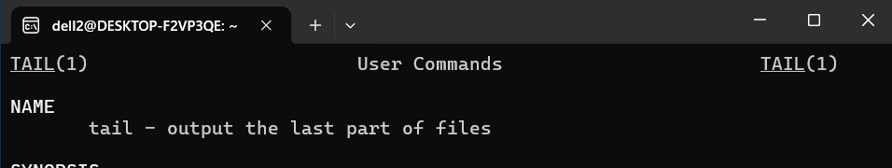
The tail command outputs the last parts of the command
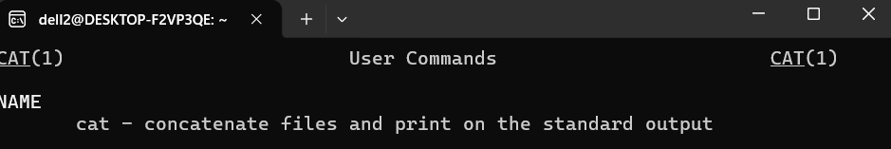
The cat is used to print out all the content of a file.
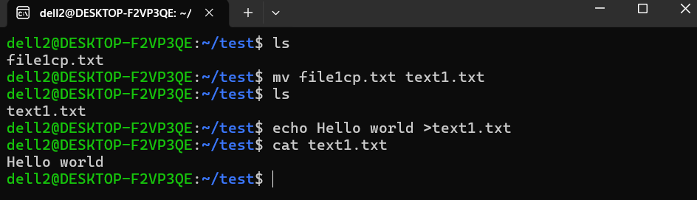
The screenshot above shows the output of the echo command which is used to put or write content into a file. The cat command is use to output what is written in the text1.txt file.
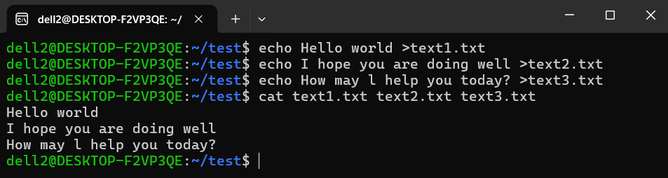
The above screenshot of my terminal shows more how the cat command can be used to output content of multiple files
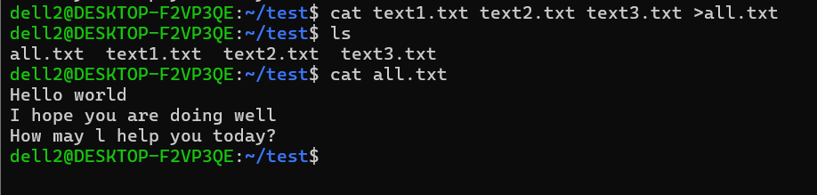
Here we see all the content of text1.txt, text2.txt, text3.txt being sent to another file called all.txt.
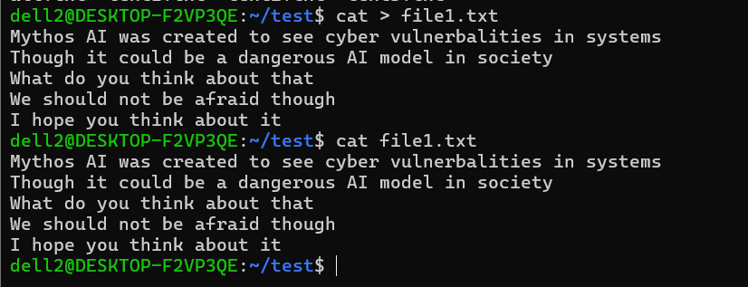
Cat can also be used to used to put multiple content in a file .as shown above. In order to exit that you have to first save the content by pressing ctrl and d

